Energy Market Price Response Service
Table-based Dispatch Algorithm for Energy Arbitrage
T. A. Edmunds
Lawrence Livermore National Laboratory

February 2018

The Energy Market Price Response (EMPR) service is provided by the device, which shifts demand from high price periods in the day to low price periods. The device would consume energy when prices are low and release energy (or defer consumption) when prices are high. This load shifting benefits the individual consumers and society in general by shifting consumption to periods when production resources are available at lower costs. The service could be driven by price forecasts of the day-ahead market or shorter time periods. The service could be facilitated by demand response aggregators, utilities, or other load serving entities. The service and modeling approaches are described in Section 4.2 of the recommended best practice report for grid services.
This paper describes a simple table-based dispatch algorithm and code implementation that finds optimal charge and discharge times for devices. The code uses a forecast of energy prices (price[t]), a round trip efficiency for the device (eff[t1,t2]), and demand elasticity in the form of a strike price or inconvenience fee for cycling the device to find an optimal pair of charge and discharge hours (strike[t1,t2]). Other parameters that constrain the optimization include the number of timesteps in the planning horizon (timesteps), the charge state at the beginning of the planning horizon (charged[0]), the number of timesteps required to fully charge or discharge the device (nChg), and a timestep at which the device must be fully charged (tFull). The variable names used in the code for these parameters are in parentheses.
The code computes the profit for each pair of charge and discharge periods (profit[t1,t2]) and the value to the consumer for each pair of time periods (value[t1,t2]). The values are computed as follows:
profit[t1,t2] = -price[t1] + eff[t1,t2]*price[t2] (1)
value[t1,t2] = profit[t1,t2] - strike[t1,t2] (2)

The code finds maximum element in the value matrix and writes out the value and the pair of hours corresponding to this maximum value. The computation is performed assuming the device only cycles once or twice per planning period and writes out both results. The code generates and displays graphs and heat maps of the input and output data. A flow diagram is shown in Figure 1.

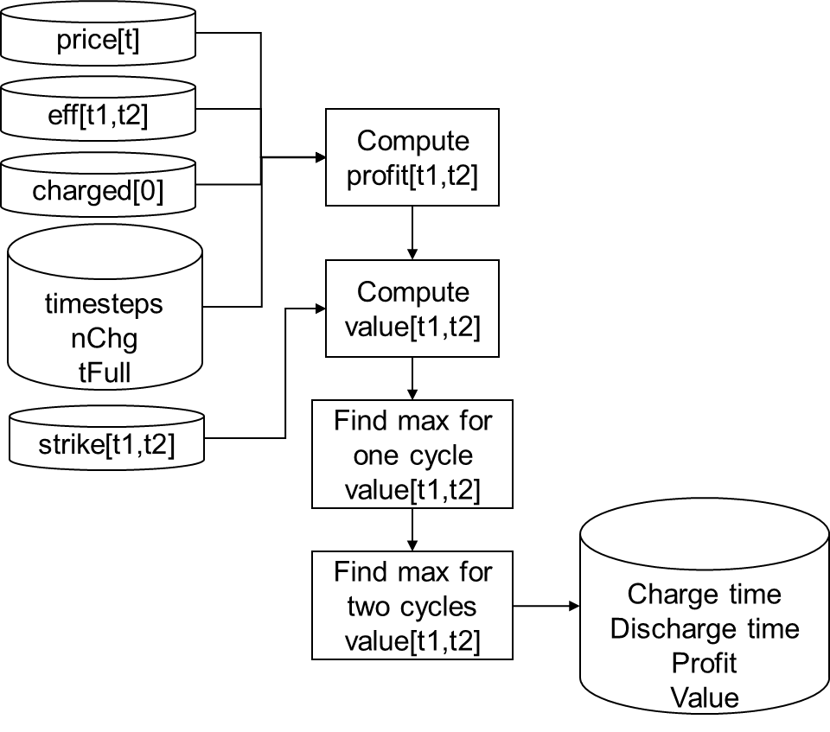
Figure 1. Dispatch table code flowchart
The input data and computed output are shown in the next few figures. Figure 2 shows marginal price data for the California Independent System Operator (CAISO) at 5 minute intervals during March 2016. This two-peak price pattern is typical of CAISO during the fall, winter, and spring seasons. It is clear from this pattern that a device would maximize profit by cycling twice per day. During the summer months there is a single peak price pattern, so a single daily cycle would be optimal.
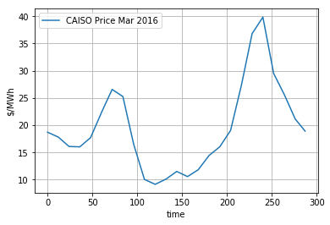
Figure 2. CAISO marginal prices at 5 minute intervals in March 2016
Round trip efficiencies for charge-discharge cycles for all pairs of five-minute time periods in the day are shown in Figure 3. In general, device modelers would provide this information. For algorithm development, this pattern was used. In general, if the device is required to hold the charge for longer periods, the round-trip efficiency is reduced. This pattern is clear on the bottom axis where the color changes from green (high efficiency) to red (low efficiency). In the region above the diagonal, charge time is later than the discharge time, implying the device was initially charged. In the region below the diagonal, the device is initially charged.
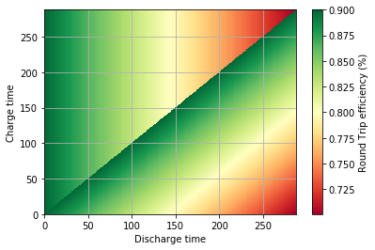
Figure 3. Round trip efficiency
If multiple timesteps are required to charge of discharge (nChg > 1), the computations for energy arbitrate profit in Equation (1) are applied for each timestep. Results from the profit computation are shown for all pairs of five-minute time intervals in Figure 4. As indicated by the green regions in left and right portions of the figure, it is advantageous to discharge during morning and evening peak prices and recharge during midday with prices are low. The red regions at the top and bottom of the figure indicate that negative profits would be realized by discharging at midday and charging during the evening or morning peak prices. In this example, the device was initially in a discharged state at the beginning of the planning horizon.

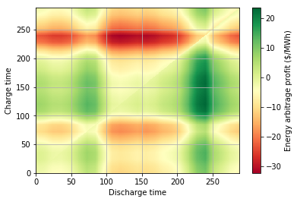
Figure 4. Profit from energy arbitrage
The strike price is a representation of demand elasticity. It represents a user inconvenience of cycling the device and is measured as $/MWh cycled. An example is shown in Figure 5, where times are expressed in five-minute intervals. The data in the figure reflect a high reluctance to charge the device after period 200, during evening peak load (green bar). The inconvenience factor is $20/MWh to charge during this time period. There is a lower level of inconvenience during the morning peak load period (yellow bar). The inconvenience factor to charge is $10/MWh during this time period.
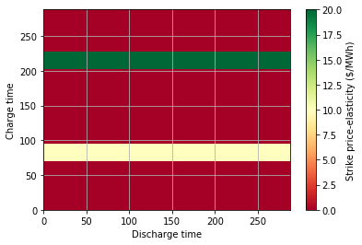
Figure 5. Strike price (demand elasticity)
The results of the value computation using Equation (2) are shown in Figure 6, where time is measured in five minute intervals. Comparing the value heat map with the profit heat map in Figure 4, one can see the effects of introducing the demand elasticity penalties. The value function is lower on the two horizontal bands for charge time where a significant demand elasticity penalty is incurred. Note the change in scale between the two figures.
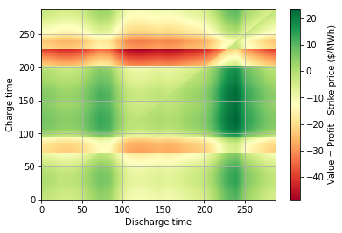
Figure 6. Value

The code writes an output file in CSV format with an echo of key input parameters and the optimal dispatch orders for one and two daily charge-discharge cycles. An example output for a one cycle dispatch is shown in Table 1. As shown in the table, the file includes a header line with a list of all the variable output, followed by the values of the variables. In this example, the optimal dispatch is to charge at timestep 119 and discharge at 238 to generate a value of $69.47/MWh. The portion of the file showing the optimal two cycle dispatch is shown in Table 2. Note that for this run, the value of tFull was set to a value of 500. Since this is beyond the planning horizon of 288 time periods, the constraint was not active.

Table 1. Input echo and optimal dispatch orders for one cycle dispatch
Single cycle output:, timesteps, startT, stopT, charged[startT], nChg, tFull, maxValue, chargeMax, dischargeMax
288
0
287
0.0
3
500
69.4718489404
119
238

Table 2. Input echo and optimal dispatch orders for two cycle dispatch
First cycle output:, timesteps, startT, stopT, charged[startT], nChg, tFull, maxValue, chargeMax, dischargeMax
288
0
143
0.0
3
500
21.2345491071
34
72
Second cycle output:, timesteps, startT, stopT, charged[startT], nChg, tFull, maxValue, chargeMax, dischargeMax
288
144
287
1.0
3
500
29.1980770365
284
238

In addition, a constraint was introduced requiring the device to be fully charged at timestep 50 (tFull = 50). The output for a single cycle is shown in Table 3. Note that the device was discharged at timestep 34 and charging began at timestep 47 and was completed by timestep 50 (nChg = 3). When this constraint is introduced, the optimal value decreases to -$0.52/MWh.

Table 3. Input echo and optimal dispatch orders with tFull = 50

Single cycle output:, timesteps, startT, stopT, charged[startT], nChg, tFull, maxValue, chargeMax, dischargeMax
288
0
287
0.0
3
50
-0.524471527939
34
47

Pratt, R., G. and Z. T. Taylor, Recommended Practice for Characterizing Devices’ Ability to Provide Grid Services, (in publication).

